LINK TO FIND Alberta Retailers:
https://www.liquorconnect.com/Products/Agents/30090700
For a list of BC retailers near you, please use our “contact us form” on our website www.castorodeoro.com to ask. (mention your city/town in the form)
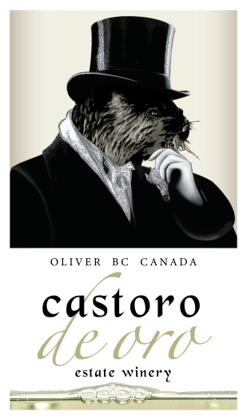
Pinot Blanc (DRY)
bottle retail before tax price $16.87
750 mL SKU# AB 765002 BC 473017 SK 22850
Chardonnay Unoaked (DRY)
bottle retail before tax price $19.04
750 mL SKU# AB 796375 BC 796375 SK 26606
can retail before tax price $7.73
250 mL SKU# AB 981460 BC 495146
Gewürztraminer Dry
bottle retail before tax price $16.87
750 mL SKU# BC 682120
Vidal
bottle retail before tax price $19.04
750 mL SKU# BC 665216
Heart of Gold (white blend) (DRY)
bottle retail before tax price $19.04
750 mL SKU# AB 285320 BC 886945
can retail before tax price $7.73
250 mL CAN SKU# AB 952900 BC 95290
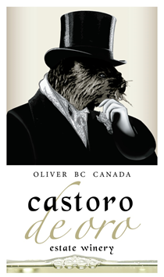
Pinot Duetto Rosé Dry
bottle retail before tax price $22.09
750 mL SKU# AB 194225 BC 194225 SK 22038
can retail before tax price $7.73
250 mL CAN SKU# AB 952870 BC 95287
Merlot
bottle retail before tax price $24.69
750 mL SKU# AB 778355 BC 604439 SK 27909
can retail before tax price $8.60
250 mL CAN SKU# AB 952930 BC 95293 SK 3858
Pinot Noir
bottle retail before tax price $24.69
750 mL SKU# AB 685891 BC 685891
Family owned and operated, 100% BC Wine!
4004 Hwy 97 Oliver, BC V0H 1T1
Facebook: @CastorodeOro Twitter: @CastoroWinery Instagram: @castorodeoro
For up to date hours regarding our on-site wine shop visit: https://g.page/castorodeoro/

