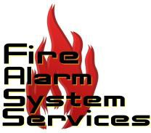

NEWS: FOR IMMEDIATE RELEASE Media Contact: Joanne Gore
Joanne Gore Communications pr@joannegorecommunications.com
+1 416 543 7951

Colin Harrold
RapidFire Colin.harrold@rapidfiress.com
+1 949 400 2592
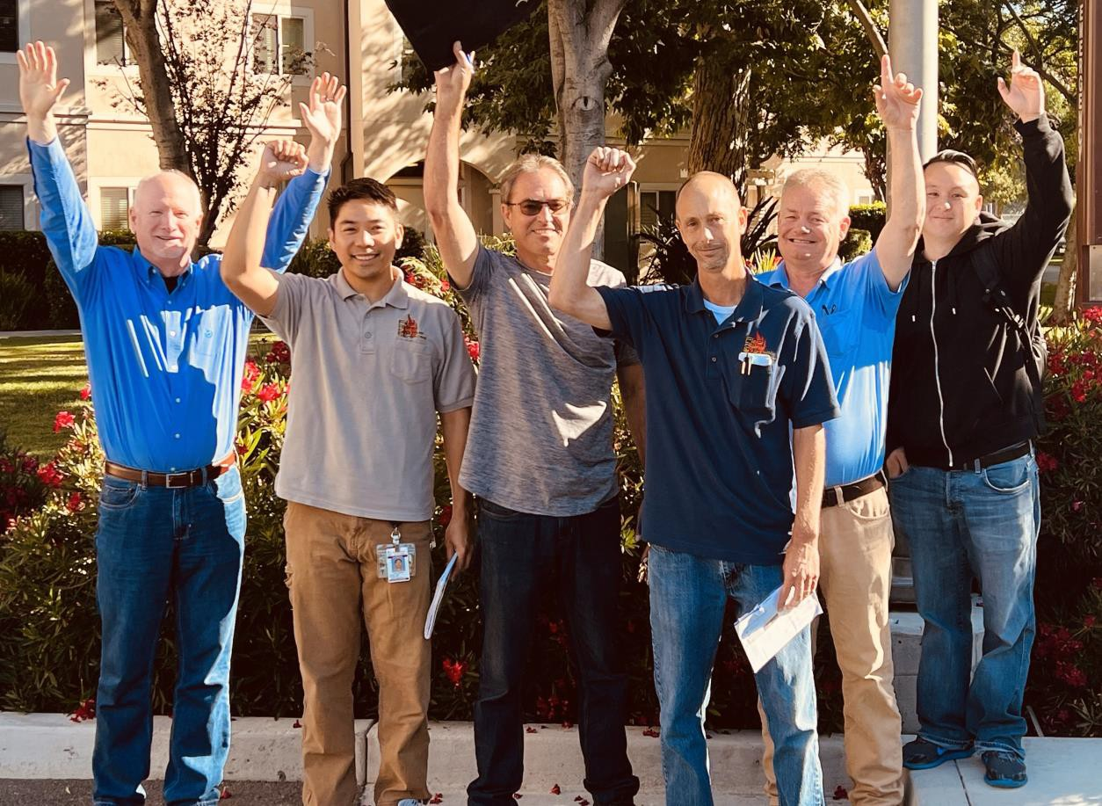

RAPIDFIRE SAFETY & SECURITY ACQUIRES FIRE ALARM SYSTEM SERVICES (FASS)
St Louis, MO. (August 17, 2023) – RapidFire Safety & Security (RapidFire), the multi- regional “Buy & Build” experts for fire safety and security industries, launched by founders Mike McLeod and Colin Harrold, and in partnership with Concentric Equity Partners, announces the acquisition of Fire Alarm System Services (FASS), a Northern-California- based provider of top-tier fire protection Inspection, Test and Maintenance (ITM) services for fire alarm, sprinkler, suppression and extinguishers. With no signs of slowing down since its founding in March 2022, this latest acquisition represents RapidFire’s continued expansion throughout the state of California.

Since 2010, the FASS team has established itself as a competitive, reliable and knowledgeable Fire Life Safety Services Provider in the Bay Area marketplace with a relationship-based mindset. Preferring to treat its customers like partners, FASS focuses on providing Quality of Service to their partners and Quality of Life to their team. Guided by the principle to “Do the right thing”, FASS is an ideal addition to the RapidFire platform and family.

Dennis Miguel, Owner of FASS stated, “We decided to move forward with Mike McLeod and the RapidFire Team and mutually avail of our common values and combined strengths to further expand our presence and better support our Partners in our marketplace.”

“Dennis has built a company with a reputation for delivering an exceptional customer experience, and we are honored to be in a position to build on that legacy as he works over the months ahead to transition to a well-deserved retirement”, said RapidFire CEO, Mike McLeod. “I am thrilled to welcome FASS as the sixth addition to RapidFire’s platform and our second in the Northern California market.”

All FASS employees will remain with the Company post-close and further expand RapidFire’s presence in the Northern California market.

“I came to know Mike McLeod professionally and personally during the diligence process and found his passion for the business and compassion for those with whom he interfaces to be admirable and consistent with my own,” continued Miguel. “As I gradually bring my 40+ year career to closure, I am reminded that while it may be hard to start and grow a business, it is even harder to let it go. I am excited about the future for RapidFire and FASS as they grow together with Mike’s leadership.”

With extensive certifications and licenses, FASS offers expert fire alarm, sprinkler, suppression, and extinguishers services; 24/7 monitoring, cost-effective solutions; AutoCad drawings for contractors; and ensures compliance with Bay Area Fire Department standards.

“The FASS team has built a reputation for world-class support and technical expertise in the Fire Life Safety business in Northern California,” stated RapidFire COO, Brian Modglin. “We are thrilled for the FASS team to join us, adding their unique capabilities and full suite of ITM services to the RapidFire platform, as we pick up speed and grow across California and the MidWest.”

###

About Fire Alarm Systems Services (FASS):
Fire Alarm Systems Services (FASS) was established in 2010 with a deep-seated commitment to offer top-tier fire protection Inspection, Test and Maintenance (ITM) services. Our primary goal is to foster enduring relationships with our customers, grounded in trust, responsiveness, and advanced technology. With a team of factory-trained professionals, FASS specializes in both current and older Fire Alarm/Life Safety Systems, continuously pushing the boundaries of knowledge and expertise. Our work ethic, mirrored in the quality of services we offer, sets us apart in the industry. However, at the heart of FASS is an understanding of the profound responsibilities we undertake — the safeguarding of lives and properties. It's this commitment, combined with the unmatched integrity of our staff and an unwavering pursuit of customer loyalty, that defines us. For FASS, excellence isn't just a goal — it's a standard, ensuring we always prioritize "Doing the Right Thing."

For more information on FASS, visit http://fassfire.com/

About RapidFire Safety & Security:
RapidFire Safety & Security is a multi-regional fire safety and security provider that offers the commercial sector comprehensive expertise in life safety and security services. Our mission is to build relationships for life by anticipating ever-changing needs and exceeding the highest expectations. We are committed to delivering an excellent experience by putting people first and fostering teamwork and personal growth. When we excel in taking care of our team members, they excel in taking care of our customers.

For more information on RapidFire, visit www.rapidfiress.com.

About Concentric Equity Partners:
Concentric Equity Partners is a private investment firm that partners with leading middle market companies by providing capital and strategic advisory to accelerate long-term value creation. Concentric’s approach is simple: support entrepreneurs and operators by providing the resources required to achieve extraordinary results. The firm’s investment team is made up of individuals with distinguished track records as operators and professional investors across a variety of growth-oriented middle-market companies.

Concentric Equity Partners is the direct investing arm of Financial Investments Corporation, a private asset management firm and family office with over $2 billion in investment commitments under management. Financial Investments Corporation was founded in 1994 by father and daughter Harrison and Jennifer Steans and has been partnering with private companies for more than 25 years.

For more information on Concentric, visit www.ficcep.com.

